Sing, Sign and Read – Hanukkah

Lesson – signs for dreidel, play, Hanukkah, candle

Song – My Dreidel
I have a little dreidel, I made it out of clay,
and when it's dry and ready, oh dreidel I shall play.
Oh dreidel, dreidel, dreidel, I made it out of clay,
and when it's dry and ready, oh dreidel I shall play.

Story – Hanukkah Lights (sign Dreidel, Hanukkah, candle)

Lesson – signs for snowflakes, 1-5

Poem – Five little Snowflakes
One little snowflake with nothing to do.
Along came another and
Then there were two.
Two little snowflakes laughing with me.
Along came another, and
Then there were three.
Three little snowflakes looking for some more.
Along came another, and
Then there were four.
Four little snowflakes dancing a jive.
Along came another, and
Then there were five.
Five little snowflakes having so much fun.
Out came the sun, and
Then there were none!

Action Song – Spinning Dreidles
Spinning Dreidles – (Frere Jacques) by Jean Warren

Spinning dreidles, spinning dreidles
Spinning ‘round, spinning ‘round
I can only spin so long
While we spin and sing this song
Then fall down, then fall down

Lesson – signs for latkes, brown, eat, up, down
Song- I'm a little latke, round and brown,
Here is my upside, here is my down.
When I am all ready, take a bite,
And eat me up on Hanukkah night.

(Isabelle imccaughey@hotmail.com )

Lesson—outside, cold, fire snow, stop, popcorn, go
Song-Let it snow
Oh the weather outside is frightful,
But the fire is so delightful,
And since we've no place to go,
Let It Snow! Let It Snow! Let It Snow!
It doesn't show signs of stopping,
And I've bought some corn for popping,
The lights are turned way down low,
Let It Snow! Let It Snow! Let It Snow!

Sing, Sing and Read – Hannukah
My Dreidel
I have a little dreidel, I made it out of clay,
and when it's dry and ready, oh dreidel I shall play.
Oh dreidel, dreidel, dreidel, I made it out of clay,
and when it's dry and ready, oh dreidel I shall play.

Spinning Dreidles – (Frere Jacques) by Jean Warren

Spinning dreidles, spinning dreidles
Spinning ‘round, spinning ‘round
I can only spin so long
While we spin and sing this song
Then fall down, then fall down

Hanukkah/Menorah
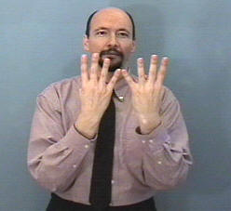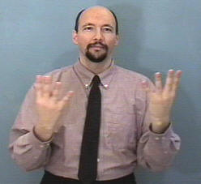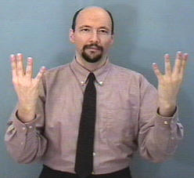

Snow
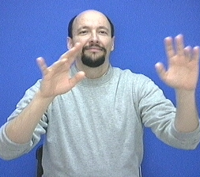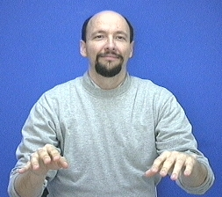
pictures courtesy of www.lifeprint.com
Oh the weather outside is frightful,
But the fire is so delightful,
And since we've no place to go,
Let It Snow! Let It Snow! Let It Snow!
It doesn't show signs of stopping,
And I've bought some corn for popping,
The lights are turned way down low,
Let It Snow! Let It Snow! Let It Snow!

Sing, Sing and Read – Hannukah
My Dreidel
I have a little dreidel, I made it out of clay,
and when it's dry and ready, oh dreidel I shall play.
Oh dreidel, dreidel, dreidel, I made it out of clay,
and when it's dry and ready, oh dreidel I shall play.

Spinning Dreidles – (Frere Jacques) by Jean Warren

Spinning dreidles, spinning dreidles
Spinning ‘round, spinning ‘round
I can only spin so long
While we spin and sing this song
Then fall down, then fall down

Hanukkah/Menorah

Snow
pictures courtesy of www.lifeprint.com
Oh the weather outside is frightful,
But the fire is so delightful,
And since we've no place to go,
Let It Snow! Let It Snow! Let It Snow!
It doesn't show signs of stopping,
And I've bought some corn for popping,
The lights are turned way down low,
Let It Snow! Let It Snow! Let It Snow!

