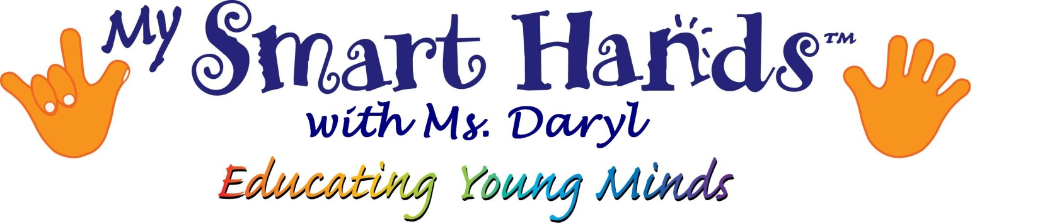Daryl Everett, Sign Language Instructor and Certified Teacher
Jacksonville, Florida 32220
(904) 237-4526 daryl@mysmarthands.com http://mysmarthandswithmsdaryl.weebly.com

Registration Form
Center/School
Educator name |  | Ages taught
Mailing Address
Telephone | ( )
Email Address
Payment Method | Cash/Check/Pay Pal/Google
Class Selection | Dates:_________________  Educator Workshop Level 1  Introductory rate: $35 materials fee + $25 tuition  ____ Yes ___ No I am a secondary attendee from my center and do not wish to receive a manual, please adjust my tuition accordingly.  MANUAL INCLUDED in full tuition only * All prices include any applicable taxes.
Please advise the instructor of any know allergies, disabilities or learning disabilities which may affect our session prior to the commencement of classes.
HOW TO REGISTER?
Complete this registration form and return it to Daryl Everett.
Electronic registration (mailto:daryl@mysmarthands.com?subject=My Smart Hands Registration) is also accepted with payment through Paypal/Google checkout. Because of our dedication to quality instruction through small class sizes, we can only hold a space upon the receipt of non-refundable retainer fee equal to materials fee. In the case of discounted rates, full tuition is due at registration.

CLASS CANCELLATION, WITHDRAWAL POLICY and NSF CHECKS
If a class is cancelled by the instructor, a make-up class or refund will be offered. There is no withdrawal policy, please discuss with instructor. A service charge of $20 will be assessed for all NSF checks. All classes are subject to appropriate demand.
FREEDOM OF INFORMATION & PROTECTION OF PRIVACY
The personal information collected through My Smart Hands registration process will be used for registration, administration, teaching, and planning purposes. Non-financial information may be shared with other students and parents for the purposes of the educational program. We will not sell your information to outside companies.
USE OF PHOTOGRAPHY / IMAGES
The participant hereby grants permission to My Smart Hands to utilize photograph(s) of themselves in such literature, brochures and website for the use of promotion and advertise its program. Names will not appear in any such publication. The participant acknowledges that presentation of photograph(s) of themselves will not be a breach to privacy.
I AGREE I DO NOT AGREE
Signature | Name
 | Date

We would like to thank you for choosing My Smart Hands educator workshop!

