Lesson 6 Readings

American Sign Language: "time"

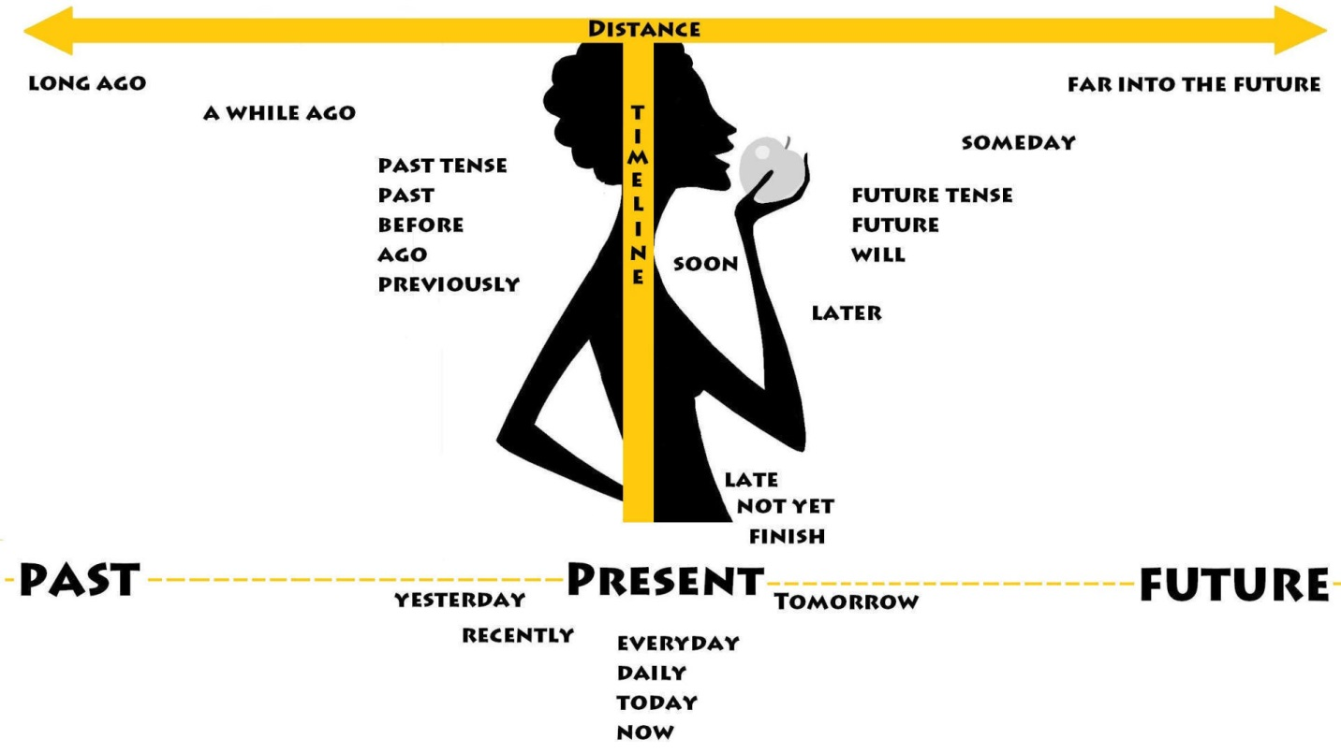

The sign for "time" in ASL points to the wrist at the location where people used to wear watches, (before cell phones). Just tap your wrist twice. If you want to know "What time is it?" then do this same sign but with furrowed eyebrows.
TIME:
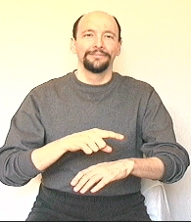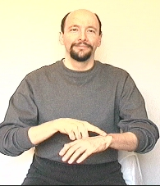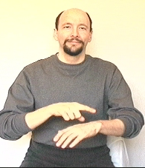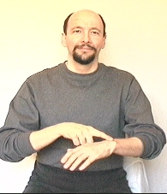

STUDENT: "How would u sign " on time"? would u sign "on" and then "time?"
Dr. Bill: You do not use the sign ON for the concept of "on time."
Instead, you should do a modified version of TIME by starting the movement from about 7 inches above the wrist, coming down quickly, touching the wrist without stopping and then moving back up 5 inches. The whole movement is very quick. Think of a scorpion stinging.
This sign could be used to mean "punctual" or 7 p.m. "sharp!"

Incorporation of number in time: example: "1 o'clock."
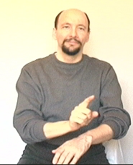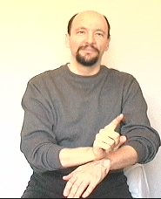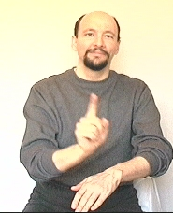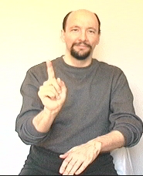

Three o'clock: 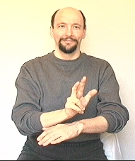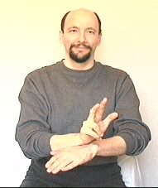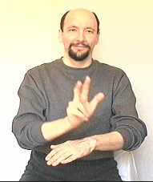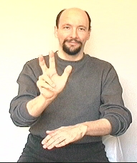

a.m. and p.m.
You can indicate "a.m." by signing "morning," or "p.m." by signing "evening."

Time Line:
The general concept here is that you have a timeline that runs from behind you to in front of you. By doing a sign farther back you can indicate the concept occurred further in the past. The farther forward things are signed, the further in the future they are. Doing a sign close to your body can be used to indicate the nearness or recentness of an event.

Dealing with time:
In English a person might say, "I went to a movie last Saturday." Or, maybe "Last Saturday I went to a movie." Notice how the concept of "go" is expressed as "went?" This is called "conjugating" the verb to show tense. (Conjugate is just a big word that means "change" or "join.") Another word for conjugate is "inflect."
In ASL that sentence would be signed "PAST SATURDAY ME-(PRO1) GO MOVIE." (The "PRO1" means a first person pronoun, which is done by simply pointing at yourself with an index finger.) We use the same form of the concept "GO" for both present and past tense sentences. That is the way it is with most ASL sentences. We establish the "tense" or time-frame of a sentence by using certain "time signs" like "past week," "next month," "now morning," or "next year," and then the rest of the sentence uses typical non-conjugated signs. This technique works for whole paragraphs and/or conversations. Tense only needs to be established once at the beginning of an ASL conversation. All of the remaining signs use the same form regardless whether you are talking about the past, present, or future. For example, in the sentence, "TOMORROW ME-(PRO1) GO MOVIE" uses the same sign for "GO" as the sentence, "YESTERDAY ME GO MOVIE."
Now note, that the interpretation of "NOW AFTERNOON ME-(PRO1) GO MOVIE" depends on what time of day it is. If it is morning, then the sentence would be the equivalent of, "This afternoon I will go to a movie." If it is currently night time, the sentence would be interpreted as, "Today I went to a movie." The ASL signs are the same, but their meaning depends on what time of day the sentence is being signed.

Dear Dr. Bill,
I have a question concerning time. Is the sign the same if you were saying "every time" or "the last time"?
- Janice
Dear Janice,
Depending on the circumstance, "every time" might be signed " EACH TIME, ALWAYS, ALL TIME, PERIOD, NO-MATTER, etc.
How you sign "the last time," depends on whether you mean "final/concluding" or "the most recent time." If you mean "the last time" as in "This is the last time we will visit this restaurant" you would use the version of the sign "LAST" that strikes the pinkie of the non-dominant hand with the pinkie of the dominant hand. If you mean, "The last time I visited this restaurant was five years ago," you would use a combination of signs including "PAST/previously" and the sign "SINCE/up to now" combined with appropriate facial grammar (slight negative head shake to indicate "haven't"). I TOUCH HERE 5-YEAR-AGO, SINCE NONE.
Thus, the traditional sign "TIME" might not even show up in the sentence.
Cordially,
- Dr. Bill
(Lifeprint.com)

numbers 100-900

Note: Don't get hung up on making perfect "C" handshapes. I'm not doing the "flying pinkie" on purpose in some of the following signs. It is just a straggler. But I'm not concerned about it either. It's a non-issue. When you practice, go ahead and use a "good looking" C handshape, but realize that later on as you become fluent the shape will "morph" a bit.
To sign numbers 101 through 109 I just show 1-0-1, 1-0-2, 1-0-3...1-0-9. Meaning, I show the individual number "one," quickly followed by a "zero," and another "one" to show the number 101.
Some people sign: 1C1 to mean 101. Or they use a modified "index-finger-C" (see below) followed by a 1.
I prefer the "zero" method.
The rest of the "hundred" series (111, through 199) you just show the number 100 (1-C) followed by the second number. You'd sign 111 by showing a "one" then a "C" then the number eleven. Use that system from 111 through 199.

Numbers 1-10 / 11-20 / 21-30 / 31-40 / 100-900 / 1000 and up / Fractions

Here is how I recommended you do the sign "100."
The "C" hand can be thought of as being similar to the Roman numeral "C" which equals 100.
You can use the "C method" for all of the 100's signs from 100 to 900 if you want.
100:
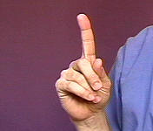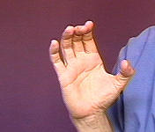
Note: You might see the number 100 done as, "1X."
I do NOT recommend the 1X version for students.
Why?
Several of my close friends and associates consider "1X" to be "wrong." They are very adamant (strong willed) about it.
On the other hand, some of my other friends don't mind the "1X" version and even prefer it.
But since some people argue against 1X and no one argues against 1C -- I suggest you stick with the 1C version for "100."
Not recommended: "1X"
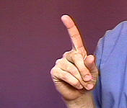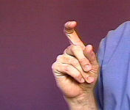

The numbers, 200, 300, 400, and 500 can use EITHER the bent fingers method or the "C" handshape method of showing the concept of "hundred." Note: 600 through 900 use the "C" version only, but realistically the handshape ends up looking somewhat like a "claw" (a loose "C.") I think the point is that on 600 - 900 you have to change the first handshape into either a "C" or a "loose C" -- you can't just bend the fingers on those. )
200:
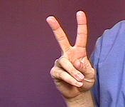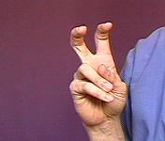

300
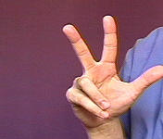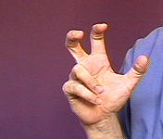

400:
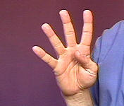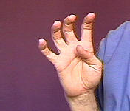

500:
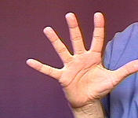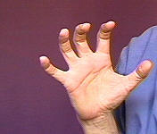

600:
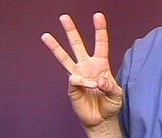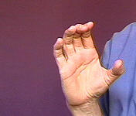

700:
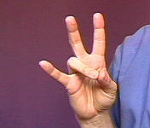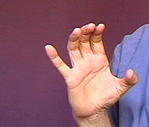
Note: Don't get hung up on making perfect "C" handshapes. I'm not doing the "flying pinkie" on purpose here. It is just a straggler. But I'm not concerned about it either. When you practice, go ahead and use a "good looking" C handshape, but realize that later on as you become fluent the shape will "morph" a bit.

800:
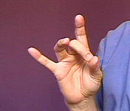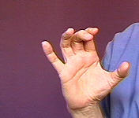

900:
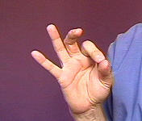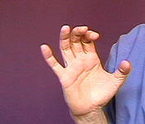

Discussion:
The number one-hundred-one is generally shown by doing: 1C01
Some people do 101 by showing the individual numbers one, zero, one (using a small sliding movement.)
I do not recommend 1C1. I suggest you do NOT do 1X1 to mean 101.

Deaf Culture
Jennifer E. Brown
4/29/03
Culture comes in many forms and is located in many different parts of the world. Culture is defined as “social and intellectual formation; the totality of socially transmitted behavior patterns, arts, beliefs, institutions, and all other products of human work and thought characteristic of a community or population” (Ed. Morris, pg 321). Being from southern Louisiana, the true south, outsiders tend to over generalize what my culture consists of based on hearsay or poor depictions from movies. For example, I have heard being from Louisiana I should be able to cook and clean. However, my favorite question I am asked without failure, “are you a coon ass”? Nothing makes me more upset than the ignorance people display when they do not take the time to find out about different cultures and how they operate. The term, “coon ass” is a racist over generalization of my culture and a demeaning label. In turn if I feel like this about my culture, then I can only imagine how persons from another culture may react to this lack of knowledge.
As a hearing person, I can only report on Deaf culture from research I have collected through reading and what I have observed from the few deaf friends I have made over the years. “D” in Deaf not only represents a culture, but also communities of people who live all over the world. The Deaf culture was born and currently thrives from shared experiences and a shared language—American Sign Language: “Mastery of ASL and skillful storytelling are highly valued in Deaf Culture. Through ASL Literature, one generation passes on to the next its wisdom, values, and its pride and thus reinforces the bonds that unite the younger generation” (ASLinfo.com). This community has its own organizations for the betterment of themselves, such as National Association of the Deaf. They also participate in athletics, theater, and competitions such as Miss Deaf America pageant. Unlike most cultures where the members of the family pass down its patterns and beliefs to further its heritage, the deaf community utilizes each member to pass down the essential richness needed to be a strong person within this community. However, this is not a traditional practice to those children born to hearing parents.
Marriage is also a part of the cultural traditions within the Deaf community. In America, nine out of ten deaf persons marry other persons from the same community. Furthermore, deaf parents would prefer that their children be born deaf so the child may be able to identify with his cultural heritage (ASLinfor.com). Persons born to a hearing world, though they may learn ASL and aspects of the Deaf culture after loss of hearing, may never acquire the full identity of being “Deaf”, nor become a full member of the Deaf community. To this community the “D” is not awarded to the person unless they are born without hearing. They have the ability to say they never heard or experienced hearing as we know in the hearing world.
Unfortunately, ugly labels have a history within this culture just as mine. Aristotle (as wise as he was supposed to be) tended to call deaf people “deaf and dumb” because he thought they could not be taught, or that they were incapable of learning. Later, “dumb” moved out and “silent” moved in as a descriptor because of how the majority of the world may have viewed deaf people. Just as “coon ass,” any and all labels are demeaning over generalizations, especially about a community of people who really are not silent. As mentioned before, ASL is the preferred use of communication in America, which is not only signing but also includes lip-reading and some individuals who may actually vocalize.
During my educational experience in graduate school at Lamar University, I would like to think I have learned a great deal about the Deaf world. Although, I have previously explored other cultures I would like to think my expedition through the Deaf culture is just beginning. Unlike some people, I do like to know what to wear to dinner, who is the dominant mate, or what the protocol for funerals are before I open my mouth. Personally, I am hungry for knowledge and willing to teach others what experiences I have gained from that knowledge. Currently, I am two weeks away from becoming a gainfully employed Audiologist, and I am more than happy I took the time to learn about Deaf culture, especially in my field. As a hearing person, you tend to think you know everything and what is best for others, but nothing is best for a community of people who thrive better than we as hearing do in the world. This is one culture anyone can sit down and take an enormous amount of notes about, yet still know nothing.
Resources
“Culture.” American Heritage Dictionary of the English Language. Ed. William Morris.
Boston: Houghton Mifflin Company, 1978. 321.

“Deaf Culture.” ASLinfo. ASLinfo.com. 1996. Houston Community College. 10 Apr.
2003. <http://www.aslinfo.com/deafculture.cfm>.

Orsi, Terri. “Deaf Culture and Deaf Community.” Deaf Education: A Parents’ Guide.
May 2001. Houston Community College. 10 Apr. 2003.
<http://home.inreach.com/torsi/culture.html>.

“What is Wrong with the Use of these Terms: ‘Deaf-mute’, ‘Deaf and dumb’, or
‘Hearing-impaired’”? National Association of the Deaf. Houston Community
College. 10 Apr. 2003. <http://www.nad.org/infocenter/infotogo/dcc/terms.html>.

