Lesson 4 Readings

American Sign Language: Nonmanual Markers (NMMs)
Nonmanual markers consist of the various facial expressions, head tilting, shoulder raising, mouthing, and similar signals that we add to our hand signs to create meaning.
The sign for nonmanual markers is to fingerspell "NMM."
Examples of nonmanual markers:
1. Slightly opening the mouth and placing the tongue over the bottom teeth so that it touches the lower lip. This nonmanual marker is used with the sign, "NOT-YET."
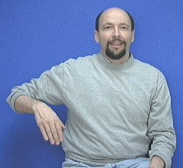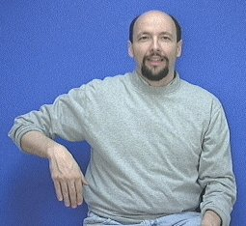
2. Bringing your cheek and your shoulder closer together while tightening the muscles in your cheek (as if you were smiling with half your face). This is often abbreviated as "c-s" meaning "cheek to shoulder." This nonmanual marker is used with signs like, "RECENT" and "THERE" to mean, "very recent" and "right there (close)."
Speakers of English tend to inflect their voices to indicate they are asking a question. Signers of ASL also inflect their questions, but instead of using voice inflection they use non-manual markers. For example:
YES/NO Question Expression:
When signing a question that can be answered "yes or no" you raise your eyebrows and tilt your head forward a bit.

"WH-Q" Question Expression:
When signing a question involving "who, what, when, where, how, how much, how many, which, or why" you use what is called a "wh" question facial expression. The "wh" facial expression "furrows" the eyebrows a bit and may tilt the head back a bit--while the body might lean forward a bit.
Here are some examples of "wh" question expression:
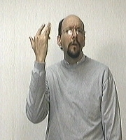 why
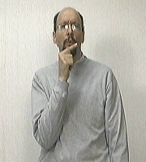 who
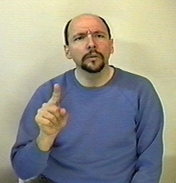where

Iconicity of Signs
Comments from Dr. Bill:
An "icon" is a symbol that looks like what it represents.
Which is to say, on some computer desktops there is a "garbage can" icon that represents a way to throw away computer files and folders.
The signs for "HOUSE" is iconic. It sort of looks like a house.
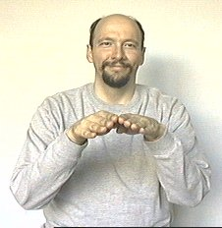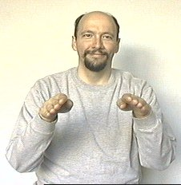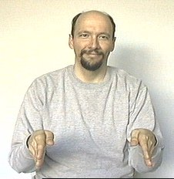
There are many iconic signs.
But there are also many signs that are not iconic or only vaguely iconic. For example, it is difficult for a sign to "look like" non-concrete concepts such as "why," "for," or "how."

American Sign Language: "Reversal of Orientation for negation"

There are a few ASL signs that can reverse their orientation to express the opposite of what the original sign meant.
For example: the sign WANT:
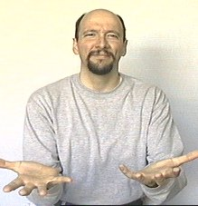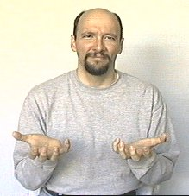
...can be changed into DON'T-WANT by doing the sign "WANT" then reversing the movement (and the orientation of the hands).
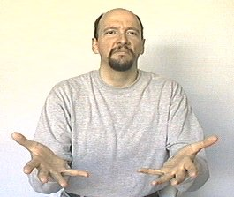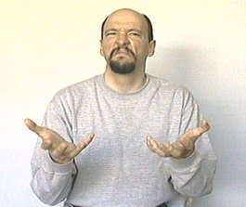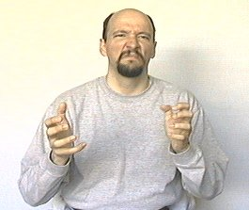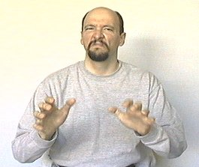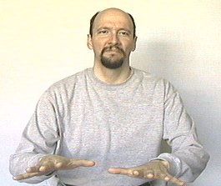
Note that doing a negative headshake and a negative facial expression helps emphasize the concept of "don't."
Some of the other signs that use reversal of orientation for negation include:
You can reverse the orientation of LIKE to mean DON'T-LIKE
You can reverse the orientation of KNOW to mean DON'T-KNOW
You can reverse the orientation of GOOD to mean BAD

American Sign Language: "Classifier: V"

The classifier known as "Classifier V" is commonly used to show how a person's legs move.
It can be used to indicate:
stand
walk-to
lying down
toss-and-turn
dive
jump
skate board
get up
fangs (snake, biting)
dollar-signs in eyes

If you specifically needed to indicate that you were walking (and not riding) or that someone is able to walk around now (as if they were bedridden before) you can use the sign "WALK-to." This means "walk over to" or "walk on your own two feet."
(See http://www.lifeprint.com/asl101/pages-signs/c/clv.htm [classifer v under lesson 4] for more information on CL:V)
Here’s a good resource for more classifer information http://www.jal.cc.il.us/ipp/Classifiers/

