LifePrint Lesson 3
Initialization
Initialization is the process of using the ASL fingerspelled letter that represents the first letter of an English word as the handshape for a sign.
For example, the signs CLASS and FAMILY are initialized signs.
FAMILY:
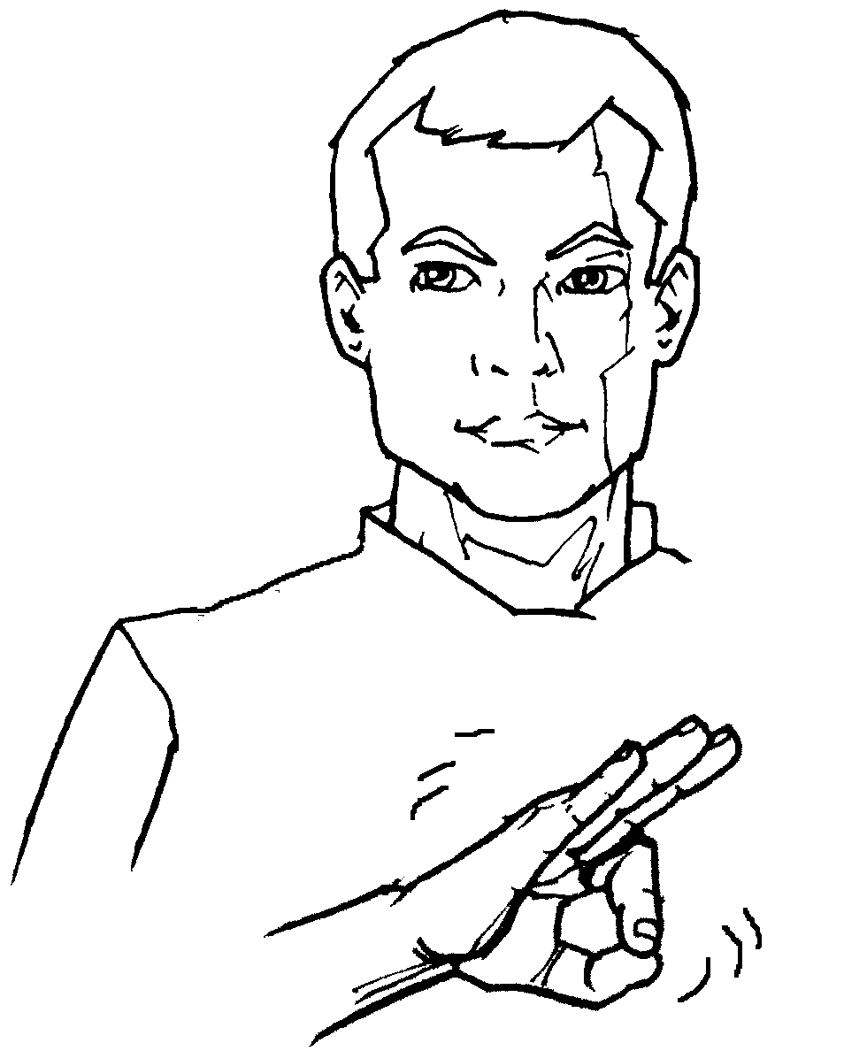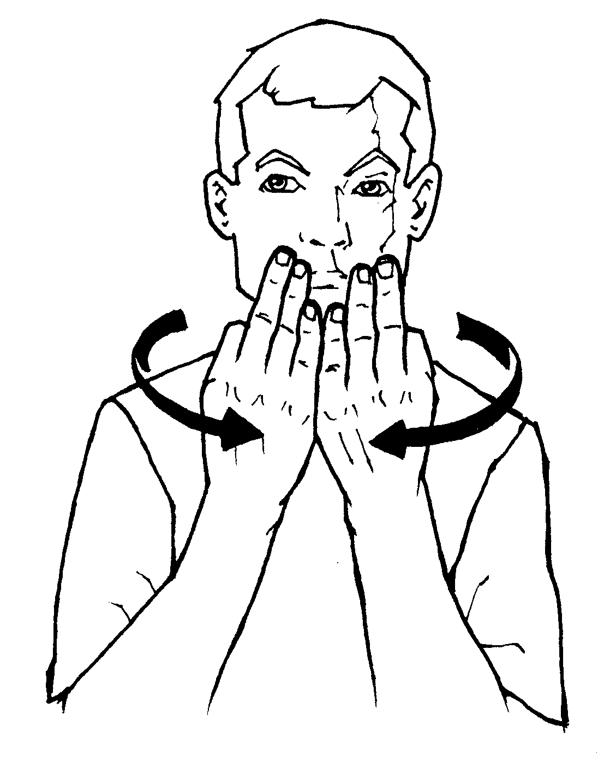
Warning: Overuse of initialization is frowned upon by the Deaf Community. While it is true that quite a few initialized signs have found their way into general usage in the Deaf community--you would do well to use initialization as little as possible if you are trying to develop your ASL skills.
(http://www.lifeprint.com/asl101/pages-layout/initialization.htm)
Topic: "Facial Expressions"
Changing your facial expression; tilting, shaking, or nodding your head; and hunching your shoulders are all "nonmanual markers." The term "nonmanual marker" means a signal that you do without using your hands that influences (marks) the meaning of what you are signing. Think of NMMs as "signs that you do without using your hands."

Topic: "grammar"
American Sign Language has its own unique syntax. You will notice that it is indeed different from that of English.. In general, the order of our words in a sentence follows a "TOPIC" "COMMENT" arrangement. This is could also called "subject" + "predicate" sentence structure. (A predicate is a word, sign, or phrase that "says something" about the subject.) For example, in the English sentence, "Sarah is sleepy." Sarah is the topic or subject. The comment or predicate consists of "is sleepy." Since ASL doesn't use "be verbs" the sentence would be signed as "SARAH SLEEPY" while nodding your head.
You will also see this structure: "TIME" + "TOPIC" + "COMMENT."
For example:
"WEEK-PAST ME WASH CAR "
or "WEEK-PAST CAR WASH ME "
I personally prefer the first version. Depending on which expert you listen to, you will hear that one way is better than the other. Anyone who tells you that ASL can't use a "subject" + "verb" + "object" sentence structure is simply denying reality. ASL uses SVO quite often. What it doesn't use is "subject" + "be-verb" + "object." For example, in ASL you wouldn't sign the "is" in "HE IS MY BROTHER." You'd simply sign "HE MY BROTHER" while nodding your head. Instead of signing "IS" you nodded your head. "IS" didn't "disappear" it simply took a "non-manual" form. Which is why we say that ASL doesn't use "be verbs." The concept of being and existing are still conveyed--but we do it without "be verbs." Instead we nod our heads, and/or use signs like "HAVE" and "TRUE."
"I am a teacher," could be signed:
"I TEACHER I"
"I TEACHER"
"TEACHER I"
also, "I am from Utah," could be signed:
"I FROM UTAH I"
"I FROM UTAH"
"FROM UTAH I"
All of the above examples are "correct." You could sign any of those sentences and still be signing ASL. My philosophy is to do the "correct" version that works for the greatest number of signers. I've lived in Utah, California, Indiana, Washington D.C., Texas, and Oregon, plus I've visited quite a few other places. It has been my experience during my various travels that "I STUDENT" and "I FROM UTAH" work just fine and are less confusing than "STUDENT I" and "FROM UTAH I."
The sentence "WHERE FROM YOU?" is used to ask where you are originally from.
As far as a sentence without "be" verbs, the English sentence "I am a teacher" would be signed:
"TEACHER ME " or even "ME TEACHER." You drop the "am" and instead nod your head.

Topic: "directionality" (verb agreement)
Dr. Bill: Suppose I index BOB on my right and FRED on my left. Then I sign "GIVE-TO" from near my body to the place where I indexed Bob. That means, "I give to Bob."
If I sign GIVE TO starting the movement from the place off to the right and move it to the left it means Bob gave to Fred. If I sign starting from off to the left and bring the sign GIVE TO toward my body what would it mean?
Sandy: "Fred give to me?"
Dr. Bill: Right.
[For more info, see: Directionality]

Topic: "Tense"
Sandy: How do you establish tense at that point?
Dr Bill: Tense would be established before signing the rest of the sentence. I would say, "YESTERDAY ME-GIVE-TO B-0-B" The fingerspelling of BOB would be immediately after the ME-GIVE-TO and I would spell B-O-B slightly more to the right than normal. That way I
wouldn't need to point to Bob. However there are three or four other acceptable ways to sign the above sentence. You could establish Bob then indicate that yesterday you gave it to him, etc.
Lii: Can tense be done at end of sentence, or is that confusing?
Dr Bill: That is confusing--I don't recommend it. I can however give you an example of "appropriately" using a time sign at the end of a sentence. Suppose I'm talking with a friend about a problem that occurred yesterday and I sign: TRY FIND-OUT WHAT-HAPPEN YESTERDAY.
Dr Bill: That sentence talks about a situation that happened before now, but the current conversation is happening now. Some people might try to put the sign "YESTERDAY" at the beginning of that sentence, but I wouldn't--it feels awkward.

Topic: "Suffixes"
Lii: How does one go about using ing, s, and ed endings ? Does it need to be done?
Dr Bill: Good question Lii...
Sandy: Similar question - how do we use punctuation--other than emphasis with the face? Just pause?
Dr Bill: Again a good question. Okay then, let me go ahead and answer both questions briefly here, then we'll hear comments from those of you who have them.
Dr Bill: "s" is a pluralization topic. You can pluralize any particular concept in a number of ways. So far in our lessons we have been using a sweeping motion, (To turn the word "HE" into the word "THEY"). "ed" is established by using a "tense marker" like PAST or is understood by
context. For example if I know you are talking about a trip you went on last week, You don't need to keep signing "PAST," I would understand it was past tense. You could sign "TRUE GOOD" and I would know you meant the trip went really well.
Dr Bill: Now, punctuation. You are right, you punctuate a sentence via your pauses and facial expressions.
Dr Bill: "ing, ed, and other suffixes are not used in ASL. If I want to change "learn" into "learning" I simply sign it twice to show it is a process. Many times the "ing" is implied. For example, "YESTERDAY I RUN" would be interpreted as "Yesterday I went for a run," or you could interpret it as, "Yesterday I went running." How you interpret it would depend on the rest of the message (context). If you want to sign dying as opposed to "die" or "dead" you would do the sign slower (more drawn out) and not quite "finish" the sign before moving on to the next sign in your sentence.

Topic: "Politically correct vs. Culturally correct"
Near the end of the twentieth century, the hearing political community pushed the idea that it was "politically correct" to call Deaf and hard of hearing people "hearing impaired." So for quite a while the general public worked hard at using the label "hearing impaired" as a way of referring to Deaf people.
This label was rejected by Deaf people. The Deaf community (a social and cultural community) prefer to be called Deaf. The term Deaf is socially and culturally correct even if certain politicians persist in calling Deaf people hearing impaired. Political correctness changes over time. What is politically correct in one community may be incorrect in another community. Politicians who are "in the know" now use the term "Deaf." For more information see my terminology discussion.

